VULNERABILITY LABS

Contents

1. CROSS – ORIGIN RESOURCE SHARING (CORS) 2

2. DOCUMENT OBJECT MODEL (DOM) 2

3. SERVER – SIDE REQUEST FORGERY (SSRF) 3

4. CROSS – SITE SCRIPTING (XSS) 3

5. AUTHENTICATION 4

6. SERVER – SIDE TEMPLATE INJECTION 4

7. COMMAND INJECTION 4

8. HTTP REQUEST SMUGGLING 5

9. CROSS – SITE REQUEST FORGERY 5

10. SQL INJECTION 6

SOLVED STATUS

# CROSS – ORIGIN RESOURCE SHARING (CORS)

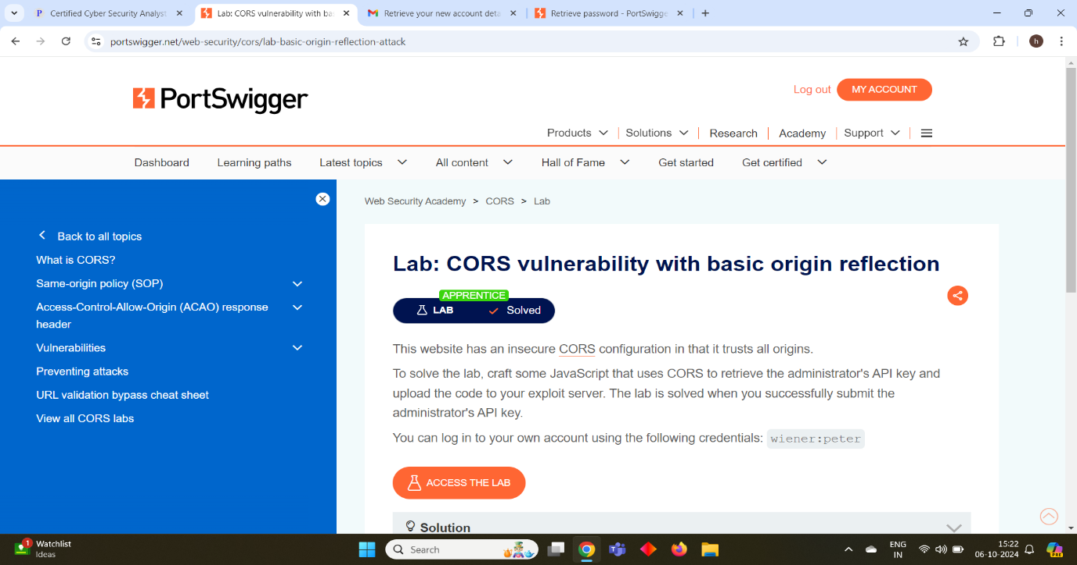

# DOCUMENT OBJECT MODEL (DOM)

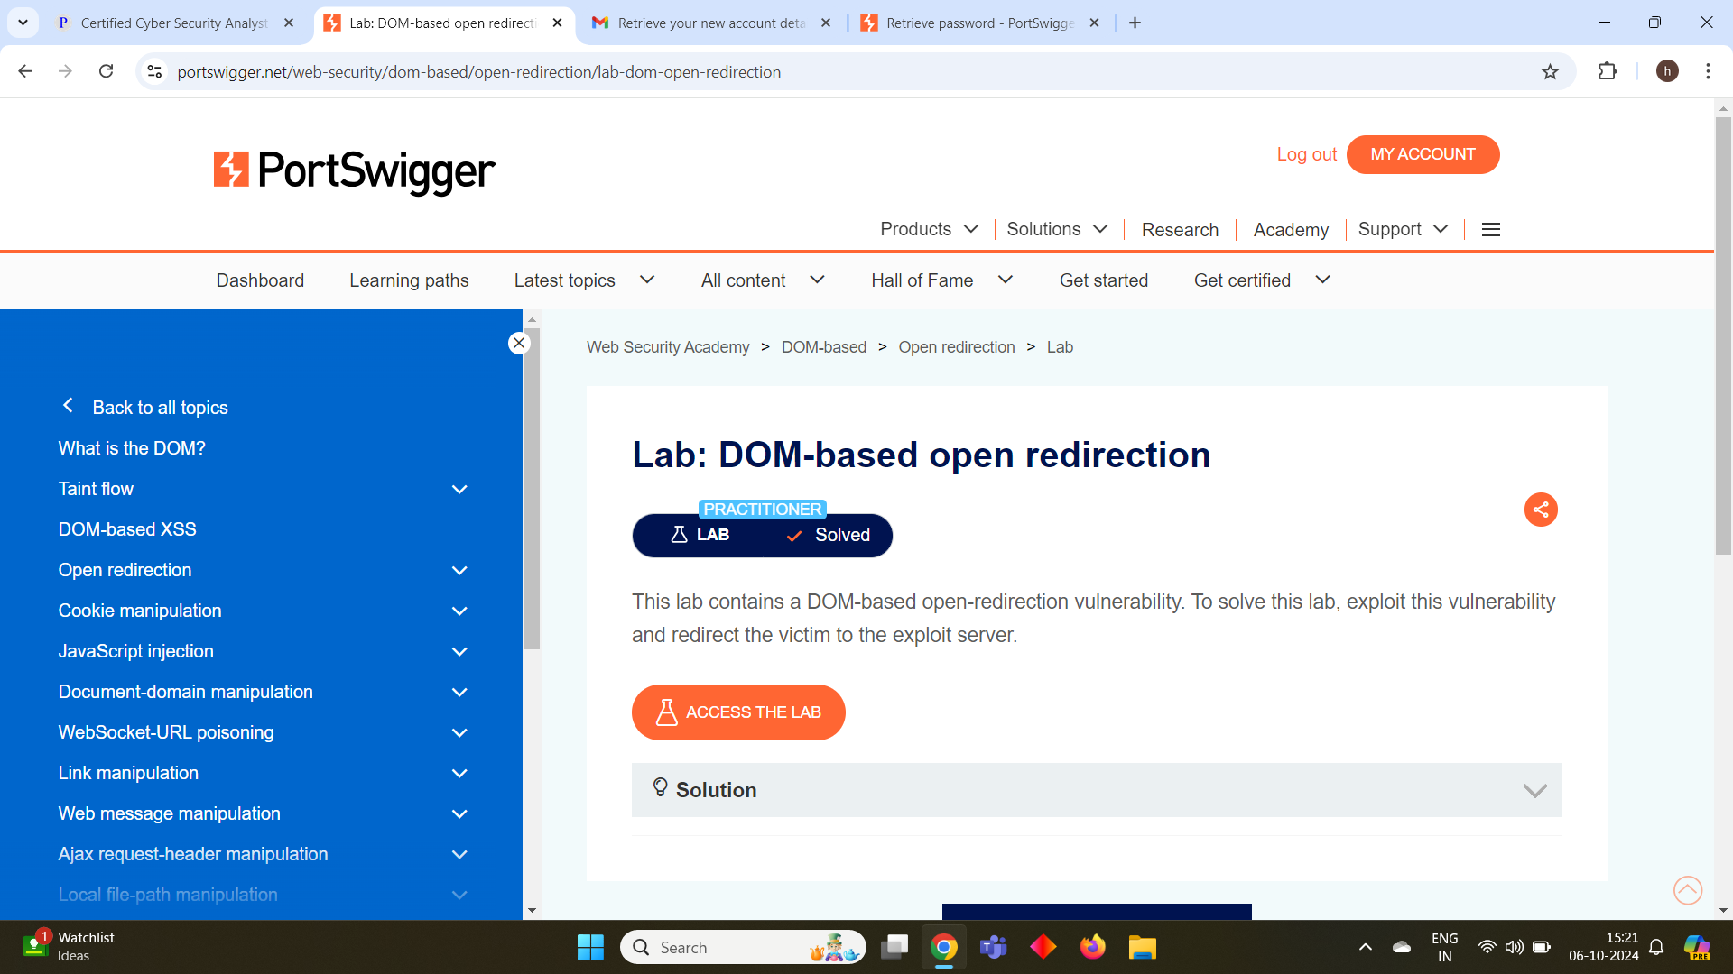

# SERVER – SIDE REQUEST FORGERY (SSRF)

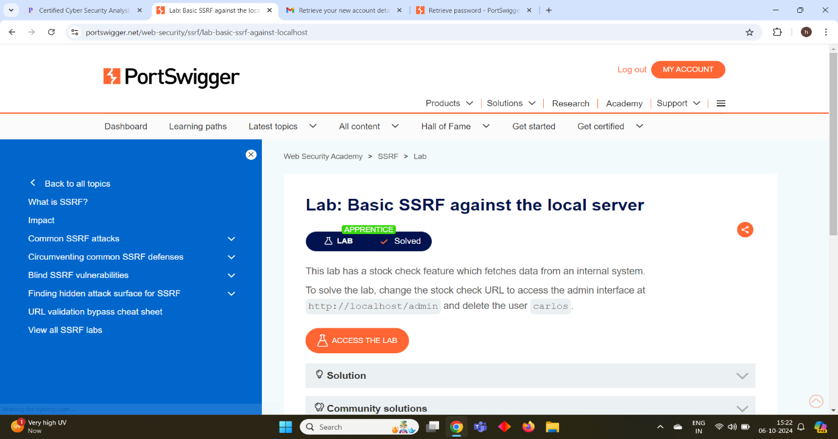

# CROSS – SITE SCRIPTING (XSS)

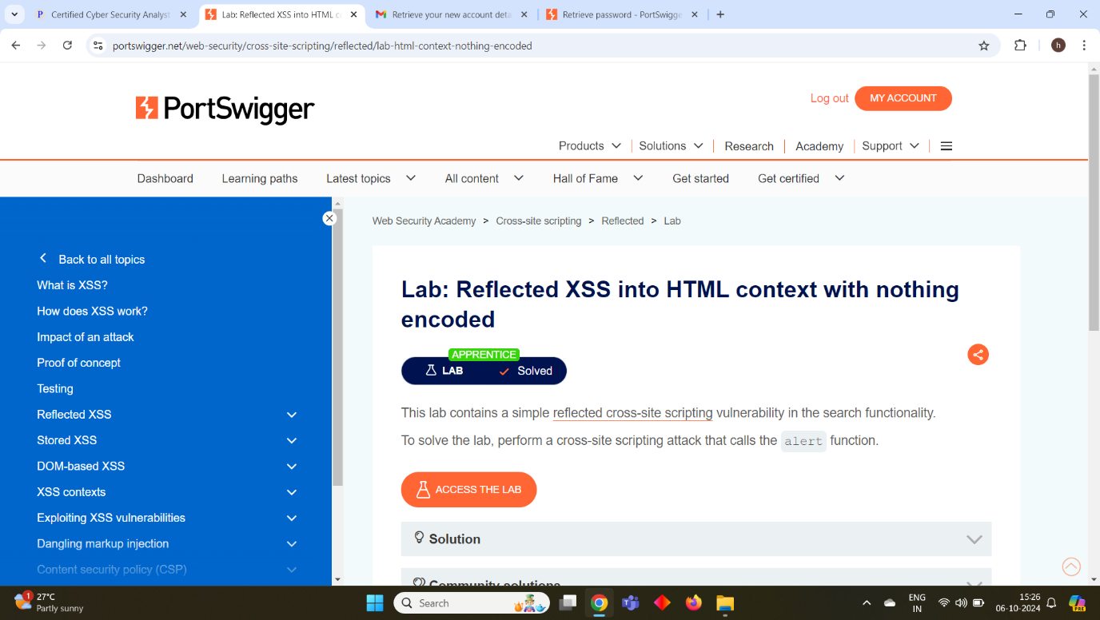

# AUTHENTICATION

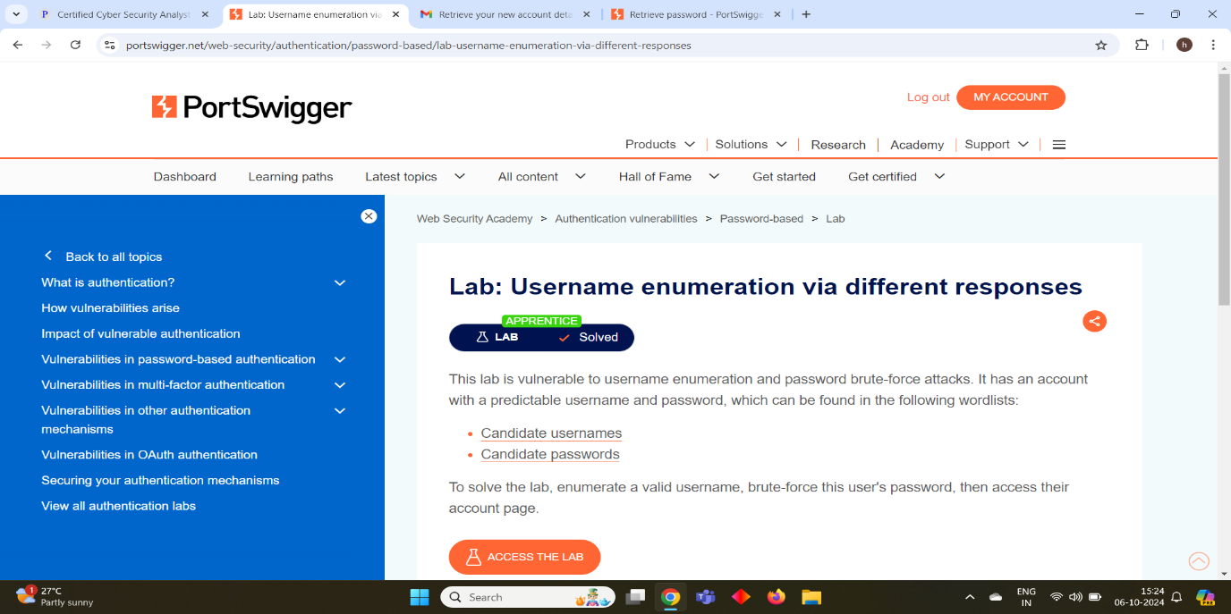

# SERVER – SIDE TEMPLATE INJECTION

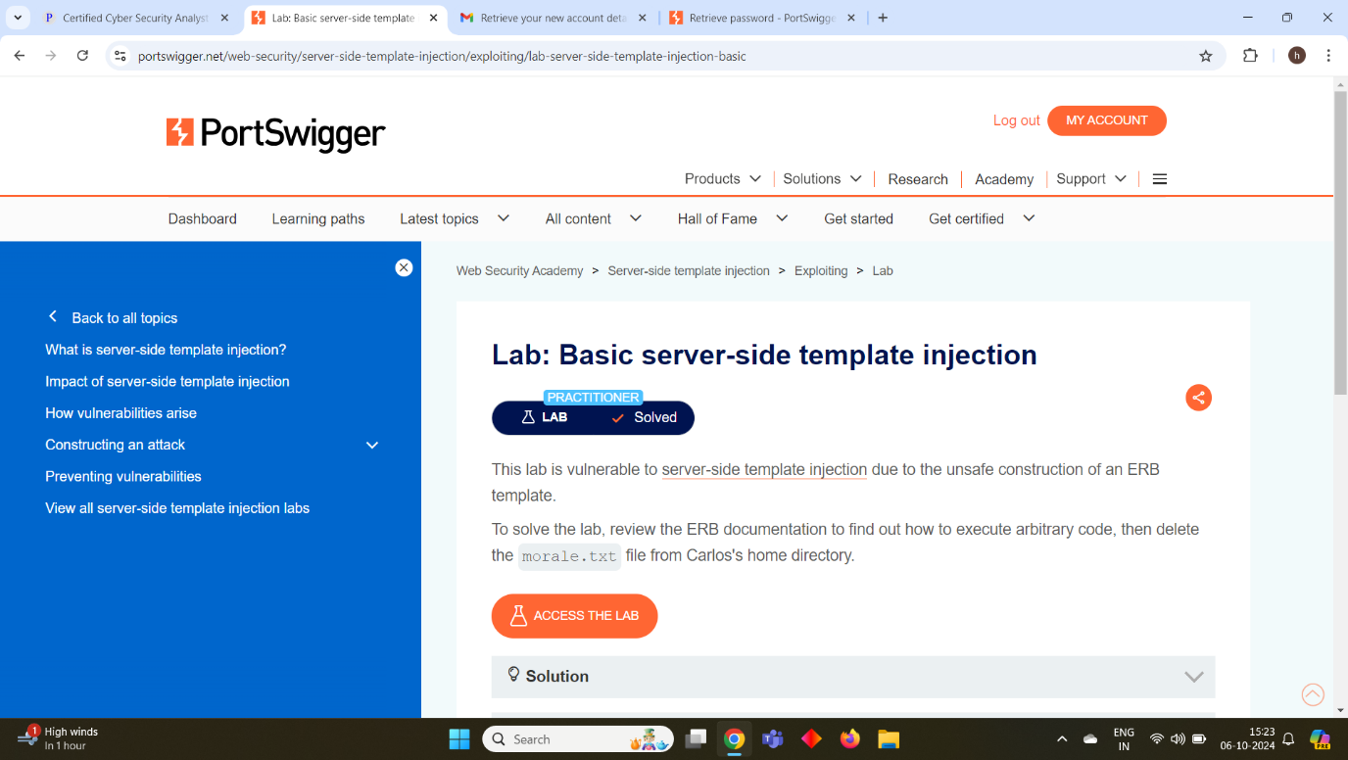

# COMMAND INJECTION

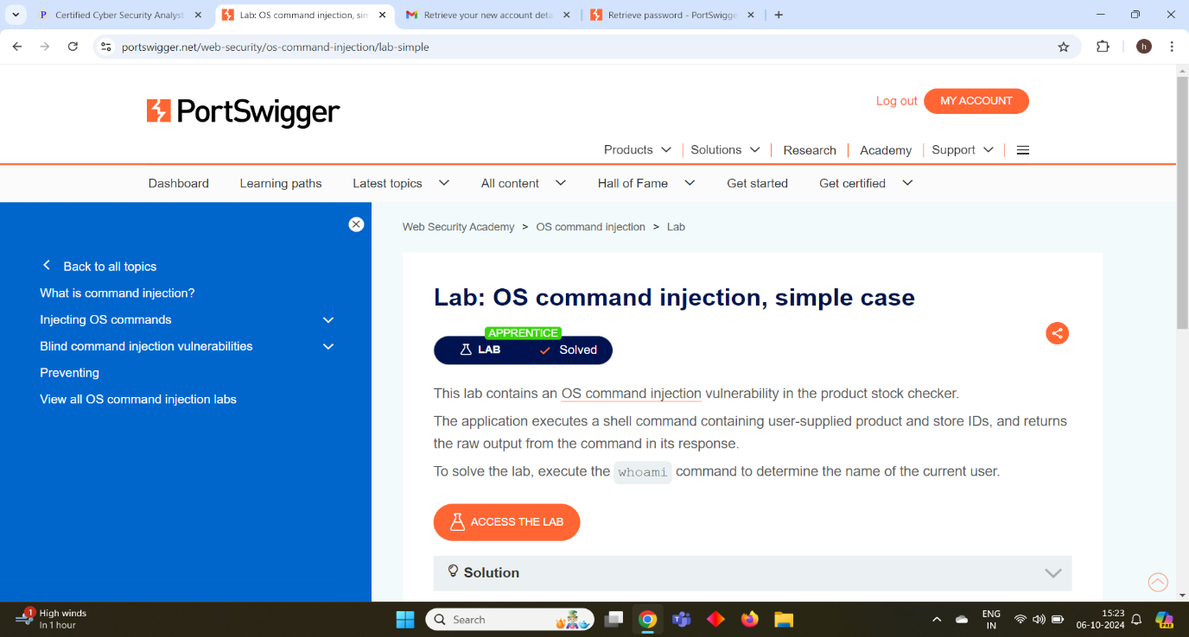

# HTTP REQUEST SMUGGLING

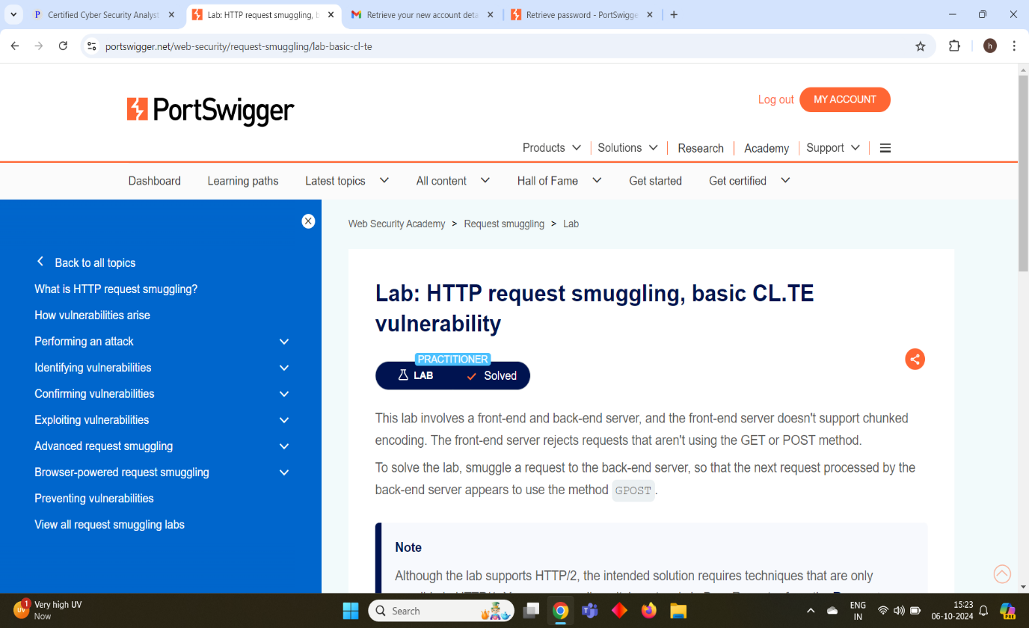

# CROSS – SITE REQUEST FORGERY

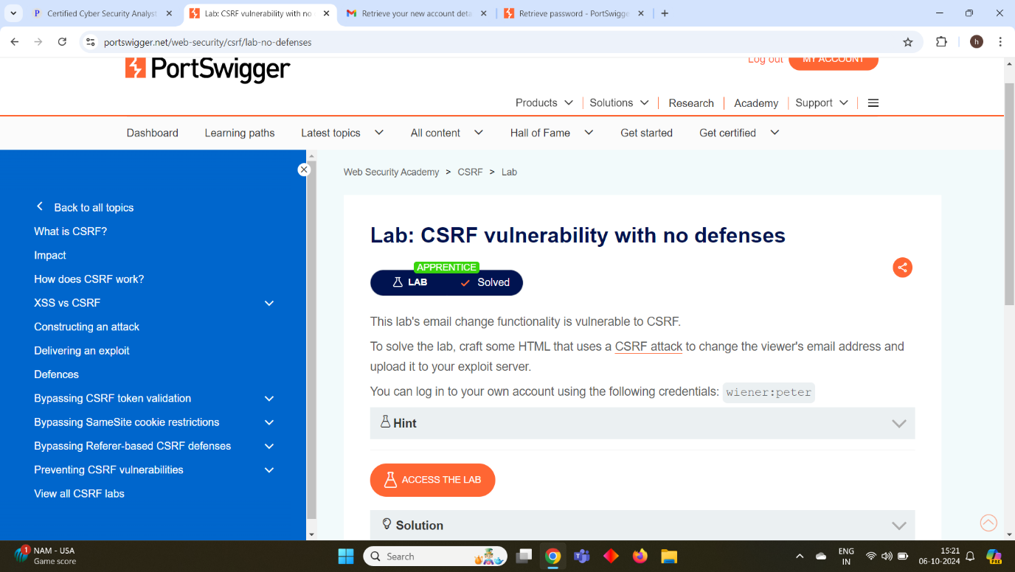

# SQL INJECTION

